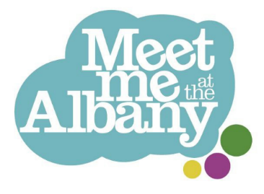
Meet Me at the Albany -
Membership form

Meet Me at the Albany is an artist-led club for people over the age of 65, offering weekly groups running on the telephone and out of The Albany in Deptford.
We welcome people who are living with long-term health conditions or dementia. Please let us know if you have any access requirements or there is anything we can do to help you take part.
Applicant details
First name: | Last name:
What do you like to be called: | Date of Birth:
Preferred Pronouns (please circle) | He/Him  She/Her  They/Them  Other:
Address: | Home phone number:
Address: | Mobile phone number:
Address: | Email address:
How can we contact you?  (please circle all that apply) | Phone call Text message  WhatsApp Email
How did you hear about us?
Interests
Please circle/highlight all that you are interested in!

Dance/
Movement Film Music Theatre


Singing Knitting/crochet Photography Painting

Anything else?:
…..................................................................................................................................

Support Needs
Do you get around: ☐ Independently
☐ With a walking stick or mobility aid
☐ With support from somebody
☐ In a wheelchair
Any further details:
……………………………………................

Is there anything you would like us to know that will help us support you at the group? Do you have any mental or physical health needs you would like to tell us about?
☐ Yes (please give further details) ☐ No
……………………………………..……………………………………..............................

Unfortunately our groups aren’t appropriate if you need support with eating, toileting or taking medication.
Please tick here to confirm you don’t need assistance with toileting, eating and taking medication ☐
Our groups can last for more than 2 hours. If you use incontinence pads, please make sure you can remain comfortable for the duration of the stay if you aren’t able to change them (as we can’t support with this). If this is the case, we may ask to speak to your care company in order to ensure your hygiene and health is put first.

Do you have any dietary requirements ☐ No
or allergies? ☐ Yes (please give details):

…………………………………..

Emergency Contact
Please give the full name and number of someone we can call in the event of an emergency:

….................................................................................................................................

Their relationship to you:

….................................................................................................................................

Your Consent

Your data will be stored safely, separately and confidentially on our central database. Please let us know if you would like to see our privacy statement

I am happy for Entelechy Arts and The Albany to store my details in their database.
Signature Date
…........................................ …..................................

Thank you for completing this form and welcome to Meet Me!

Please return this form to:

: jasmine.sparrow@entelechyarts.org
+ Entelechy Arts, The Albany, Douglas Way, London SE8 4AG
( 07593 580574 (for queries and access requests, or to go through this form over the phone)

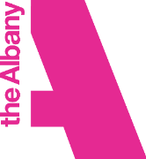
Meet Me is led by charities Entelechy Arts and the Albany.
The programme is supported by Lewisham Council, National Lottery Reaching
Communities fund as well as independent trusts and foundations.

